- HOME
WELCOME TO VJSS 2026
The 2nd Vietnam–Japan Semiconductor Symposium 2026 (VJSS 2026): Advancing Research, Education, Human Resource Development, and Industry Collaboration in Semiconductors, hosted by VNU Vietnam Japan University (VNU-VJU) and the Association of Vietnamese Intellectuals in Japan (AVIJ), will be held on September 20–23, 2026, in Hanoi, Vietnam. VJSS 2026 aims to provide a platform for researchers, educators, students, industry leaders, policymakers, and innovation stakeholders from around the world to exchange knowledge, showcase cutting-edge research, strengthen academic–industry partnerships, and foster collaborative initiatives that advance semiconductor science, technology, education, and ecosystem development.
NEWS AND ANNOUNCEMENTS
- Ngày tháng năm
- Link các tin tức về hội thảo theo thứ tự tin mới nhất trên đầu.
THEME CLUSTERS

Theme 1: Integrated Circuit Design and Verification
- IC and VLSI design methodologies
- Electronic Design Automation (EDA) and design technologies
- Circuit and system verification
- RISC-V and hardware architecture
- Security hardware
- Data-centric and energy-efficient computing systems

Theme 2: Optoelectronic Devices and Semiconductor Chip Technology
- Semiconductor devices, device physics and applications
- Optoelectronic and photonic devices
- Electronic-photonic integrated circuits and chip technologies
- Sensors, imaging, and optical communication devices
- Device integration and chip-level platforms

Theme 3: Advanced Materials Design and Smart Processing
- Silicon, SiC, compound semiconductors, and nitride semiconductors
- Ferroelectric, magnetic, organic, perovskite, and two-dimensional materials
- Materials design, characterization, and processing
- Smart manufacturing and semiconductor process innovation
- Defects, interfaces, reliability, and materials informatics

Theme 4: Advanced Packaging and Testing
- Advanced packaging technologies
- Heterogeneous integration
- Thermal management and phonon engineering
- Reliability, testing, and evaluation
- Packaging for high-performance, high-reliability, and mass-production-ready systems

Theme 5: AI and Quantum Computing in Semiconductors
- AI-assisted semiconductor design, processing, and characterization
- Quantum materials and quantum devices
- Spintronics and new computing paradigms
- Semiconductor platforms for quantum and neuromorphic computing
- AI, data science, and automation in semiconductor research and manufacturing

Theme 6: Emerging Semiconductor Frontiers
- MEMS and sensor technologies
- Flexible and organic electronics
- Gas sensors and environmental sensing technologies
- Frontier semiconductor materials and novel devices
- Emerging concepts and next-generation semiconductor applications applications

Theme 7: Human Resource Development and Academic-Industrial Collaboration
- Semiconductor education and curriculum development
- Joint training programs and international education models
- Internships, recruitment, and career development
- University-industry collaboration and technology transfer
- Policy, innovation ecosystems, and Vietnam-Japan semiconductor cooperation

KEY DATES
Abstract Submission Deadline | July 31, 2026
Abstract Notification of Acceptance | August 15, 2026
Full Paper Submission Deadline, if applicable | October 30, 2026
Full Paper Notification of Acceptance, if applicable | December 15, 2026
Early Bird Registration Deadline | July 31, 2026
Registration Deadline | August 31, 2026
Conference Dates | September 20-23, 2026

CONFERENCE VENUE
The conference will be held in Hanoi, Vietnam, September 20-23, 2026
Venue: Vietnam National University / Sheraton Hanoi West, final confirmation pending

- CALL FOR PAPERS
BACKGROUND
Semiconductors are driving the next generation of technologies, including artificial intelligence, advanced manufacturing, quantum computing, and digital infrastructure. As the global semiconductor landscape continues to evolve, international collaboration in research, education, talent development, and industry has become increasingly important.
Japan has long been a global leader in semiconductor science and technology, while Vietnam is rapidly emerging as a promising semiconductor hub through strategic investments in education, research, and innovation. Building on these complementary strengths, VJSS 2026 aims to bring together researchers, students, universities, industry leaders, and policymakers from Vietnam, Japan, and around the world to exchange knowledge, foster collaboration, and promote sustainable development of the global semiconductor ecosystem.
OBJECTIVES
The key objectives of VJSS 2026 are to:
- Advance Vietnam-Japan academic exchange and research collaboration in semiconductor science and engineering;
- Foster interdisciplinary dialogue across semiconductor design, devices, materials, processing, packaging, testing, AI, quantum technologies, and emerging frontiers;
- Provide opportunities for young researchers and students to present their work and develop international research networks;
- Strengthen human resource development through lectures, career-oriented sessions, mentoring, internships, and industry-academia interaction;
- Create structured dialogue among universities, companies, public agencies, and innovation centers on semiconductor cooperation;
- Support long-term collaboration among Vietnam, Japan, and international partners in semiconductor education, research, and industrial ecosystem development.
THEME CLUSTERS
The symposium welcomes original contributions in, but not limited to, the following technical theme.

Theme 1: Integrated Circuit Design and Verification
- IC and VLSI design methodologies
- Electronic Design Automation (EDA) and design technologies
- Circuit and system verification
- RISC-V and hardware architecture
- Security hardware
- Data-centric and energy-efficient computing systems

Theme 2: Optoelectronic Devices and Semiconductor Chip Technology
- Semiconductor devices, device physics and applications
- Optoelectronic and photonic devices
- Electronic-photonic integrated circuits and chip technologies
- Sensors, imaging, and optical communication devices
- Device integration and chip-level platforms

Theme 3: Advanced Materials Design and Smart Processing
- Silicon, SiC, compound semiconductors, and nitride semiconductors
- Ferroelectric, magnetic, organic, perovskite, and two-dimensional materials
- Materials design, characterization, and processing
- Smart manufacturing and semiconductor process innovation
- Defects, interfaces, reliability, and materials informatics

Theme 4: Advanced Packaging and Testing
- Advanced packaging technologies
- Heterogeneous integration
- Thermal management and phonon engineering
- Reliability, testing, and evaluation
- Packaging for high-performance, high-reliability, and mass-production-ready systems

Theme 5: AI and Quantum Computing in Semiconductors
- AI-assisted semiconductor design, processing, and characterization
- Quantum materials and quantum devices
- Spintronics and new computing paradigms
- Semiconductor platforms for quantum and neuromorphic computing
- AI, data science, and automation in semiconductor research and manufacturing

Theme 6: Emerging Semiconductor Frontiers
- MEMS and sensor technologies
- Flexible and organic electronics
- Gas sensors and environmental sensing technologies
- Frontier semiconductor materials and novel devices
- Emerging concepts and next-generation semiconductor applications applications

Theme 7: Human Resource Development and Academic-Industrial Collaboration
- Semiconductor education and curriculum development
- Joint training programs and international education models
- Internships, recruitment, and career development
- University-industry collaboration and technology transfer
- Policy, innovation ecosystems, and Vietnam-Japan semiconductor cooperation
The Organizing Committee is also happy to consider other topics related to semiconductor science, technology, education, and ecosystem development.
CONFERENCE FORMAT AND VENUE
Venue: Hanoi, Vietnam
Format: In-person with hybrid participation support
SUBMISSION GUIDELINES
Authors wishing to present their work at VJSS 2026 are invited to submit an abstract in English. Each submission should include the title of the presentation, author names and affiliations, the corresponding author’s full contact information, the preferred presentation format (oral or poster), the relevant symposium theme, an abstract of approximately 200–300 words, and three to five keywords. VJSS 2026 welcomes contributions from academia, industry, and government, and particularly encourages submissions from graduate students, early-career professionals, and industry researchers.
Đính kèm format abstract template
Đính kèm format full paper template
Please submit your abstract via the online submission system at: https://vjss2026.vju.ac.vn/
PUBLISHING OPPORTUNITY
Selected contributions may be invited to submit full papers for conference proceedings, special issues, or other post-symposium publication opportunities. Detailed information regarding full-paper preparation, templates, and submission procedures will be announced in due course.
KEY DATES
Abstract Submission Deadline | July 31, 2026
Abstract Notification of Acceptance | August 15, 2026
Full Paper Submission Deadline, if applicable | October 30, 2026
Full Paper Notification of Acceptance, if applicable | December 15, 2026
Early Bird Registration Deadline | July 31, 2026
Registration Deadline | August 31, 2026
Conference Dates | September 20-23, 2026

- COMMITTEES
ORGANIZING COMMITTEE
Chairmen:
Dr. Nguyen Hoang Oanh, Rector of VNU Vietnam Japan University
Prof. Toshiro Hiramoto, JST NEXUS Program Officer
Members:
Dr. Do Ngoc Ha, VNU Vietnam Japan University
Assoc. Prof. Le Duc Anh, The University of Tokyo, Japan
Assoc. Prof. Bui Nguyen Quoc Trinh, VNU Vietnam Japan University
Dr. Pham Tien Thanh, VNU Vietnam Japan University
Assoc. Prof. Hoang Thi Minh Thao, VNU Vietnam Japan University
Assoc. Prof. Nguyen Thi An Hang, VNU Vietnam Japan University
Dr. Dang Thanh Tu, VNU Vietnam Japan University
Dr. Vu Quang Viet, VNU Vietnam Japan University
MA. Nguyen Ngoc Huong, VNU Vietnam Japan University
BA. Bui Thu Trang, VNU Vietnam Japan University

LOCAL ORGANIZING COMMITTEE
Chairman:
Assoc. Prof. Hoang Thi Minh Thao, VNU Vietnam Japan University
Members:
Dr. Do Ngoc Ha, VNU Vietnam Japan University
Assoc. Prof. Bui Nguyen Quoc Trinh, VNU Vietnam Japan University
Dr. Pham Tien Thanh, VNU Vietnam Japan University
Assoc. Prof. Nguyen Thi An Hang, VNU Vietnam Japan University
Assoc. Prof. Dao Quang Duy, VNU Vietnam Japan University
Dr. Ta Quang Ngoc, VNU Vietnam Japan University
Dr. Duong Huu Toan, VNU Vietnam Japan University
Dr. Pham Duc Tho, VNU Vietnam Japan University
Dr. Vu Quang Viet, VNU Vietnam Japan University

SCIENTIFIC COMMITTEE
Chairman:
Assoc. Prof. Bui Nguyen Quoc Trinh, VNU Vietnam Japan University
Members:
Dr. Pham Tien Thanh, VNU Vietnam Japan University
Assoc. Prof. Le Duc Anh, The University of Tokyo, Japan
Dr. Le Kim Quy, VNU Vietnam Japan University
Dr. Hoang Thi Thanh Tam, VNU Vietnam Japan University
Assoc. Prof. Dao Quang Duy, VNU Vietnam Japan University
Dr. Nakamoto Trang, Ritsumeikan University, Japan
Dr. Nguyen Thi Thanh Ngan, Tohoku University, Japan
Dr. Nguyen Thi Van Anh, Tohoku University, Japan
Dr. Ngo Hoai Nguyen, The University of Osaka, Japan
Dr. Huynh Van Nhat, Sony Semiconductor Solutions Corporation
Dr. Ngo Minh Chu, Institute of Construction Science and Technology
BS. Pham Duc Anh, VNU Vietnam Japan University

CONFERENCE SECRETARIAT
Chairman:
Dr. Vu Quang Viet, VNU Vietnam Japan University
Members:
Dr. Do Hong Minh, Le Quy Don Technical University
BA. Bui Thu Trang, VNU Vietnam Japan University
BS. Bui The Trung, VNU Vietnam Japan University
BS. Pham Duc Anh, VNU Vietnam Japan University
BS. Nguyen Tien Tao, VNU Vietnam Japan University
BS. Nguyen Van Loi, Vietnam Academy of Cryptography Techniques
BS. Ngo Quang Truong, VNU Vietnam Japan University
BA. Nguyen Thuy Lien, VNU Vietnam Japan University
BS. Vu Van Hoi, VNU Vietnam Japan University

- SPEAKERS
To be updated soon

- ORGANIZERS
Host institution
(logo kèm tên)
VNU Vietnam Japan University (VNU-VJU)
Co-host organization
Association of Vietnamese Intellectuals in Japan (AVIJ)
Patrons
Japan Science and Technology Agency (JST)
National Innovation Center (NIC), Vietnam

- SPONSORS
To be updated soon

- REGISTRATION AND FEES
Registration fees will be announced later. The registration fee is expected to cover access to symposium sessions, conference materials, coffee breaks, and selected official networking activities. Details regarding student registration, early bird registration, industry registration, and hybrid participation will be provided on the official symposium website.
- SUBMISSION & PUBLICATIONS
SUBMISSION GUIDLINES
Authors wishing to present their work at VJSS 2026 are invited to submit an abstract in English.
Each abstract should include:
• Title of the presentation
• Author names and affiliations
• Corresponding author's full contact details
• Preferred presentation format (oral or poster)
• Relevant theme cluster
• Abstract of approximately 200-300 words; and
• Three to five keywords
Submission from graduate students, early-career professionals, and industry researchers are strongly encouraged.

PUBLISHING OPPORTUNITY
Selected contributions may be invited to submit full papers for conference proceedings, special issues, or other post-symposium publication opportunities. Detailed information regarding full-paper preparation, templates, and submission procedures will be announced in due course.
Đính kèm format abstract template
Đính kèm format full paper template
Làm 1 option để khi click vào sẽ link đến hệ thống nộp bài của Easychair

- CONFERENCE VENUE
The conference will be held in Hanoi, Vietnam, September 20-23, 2026
Venue: Vietnam National University, Hanoi / Sheraton Hanoi West, final confirmation pending
Bổ sung địa chỉ google

- PROGRAM
Tentative schedule
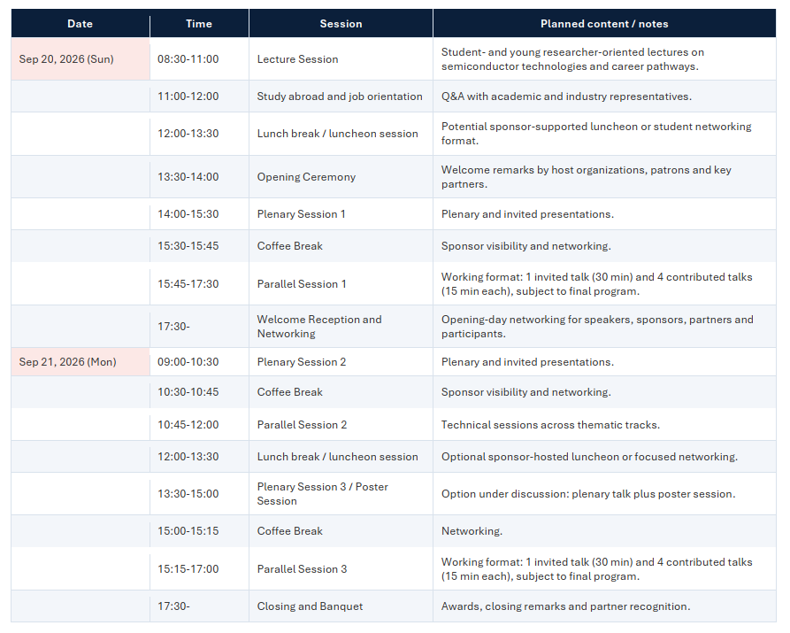
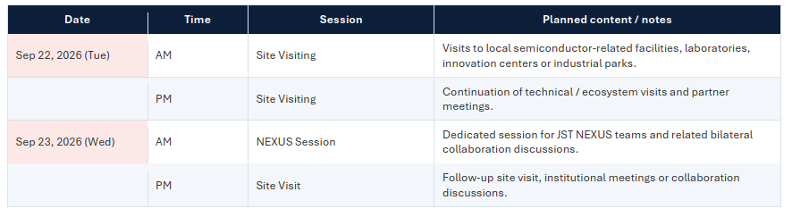
- CONTACT
Academic liaison:
1. Assoc. Prof. Le Duc Anh
University of Tokyo
2. Assoc. Prof. Bui Nguyen Quoc Trinh
VNU Vietnam Japan University
Conference secretariat:
BA. Bui Thu Trang
Phone: + 84 856389040
VNU Vietnam Japan University
Email: vjss-info@vju.ac.vn

- LOGIN
click vào sẽ link đến hệ thống nộp bài của Easychair

